**Sprint 3 Plan**

**Product name:** Peergrader

**Team name**: Peergrader

**Sprint completion date:** May 21, 2024

**Revision number:** 2

**Revision date:** May 12, 2024

**Goal:**

Maximum total hours/story points per Sprint: 60

**User Stories:**

1. User Story 3.1 [20 story points] As an instructor I want students to get a grading score based on how well they graded others.
2. User Story 3.2 [10 story points] As an instructor I want to be able to see the progress the class has made on turning in and grading.
3. User Story 3.3 [15 story points] As a student I want to be able to see the scores I have been given and what I lost points for.
4. User Story 3.4 [5 story points] As a student or teacher I want to be able to customize my profile.

**Tasks Listing:**

User Story 3.1

* Display the student’s grade
* Compute the student’s score based on the student’s score
* Compute the student’s score based on how “well” the student graded
* Rubric setting to adjust how the student gets a grade

User Story 3.2

* Display a progress bar
* Display all the students and their current progress

User Story 3.3

* Display the breakdown of the student’s scores by student
* Show which rubric rows were selected by each student
* Show the comments/feedback from other students

User Story 3.4

* Create a profile page
* Change name
* Change picture
* Change email
* Toggle notifications
* Remove yourself from a class
* Delete account

**Infrastructure:**

* Postgresql database: Supabase
* Storage (files): Supabase
* Deployment: Vercel
* GitHub: Version control
* Framework: next.js

**Team roles:**

* Christian Knab: Product owner
* Aastha Verma: Team member
* Eliah Reeves: SCRUM Master
* Eric Chuang: Team member

**Initial task assignment:**

* Aastha Verma: User Story 3.1-3.4 UI for pages
* Eliah Reeves: User Story 3.3 Display the comments from other students
* Christian Knab: User Story 3.3 Add rubric setting to adjust score breakdown
* Eric Chuang: User Story 3.1 Compute the student’s score

**Burnup Chart:**

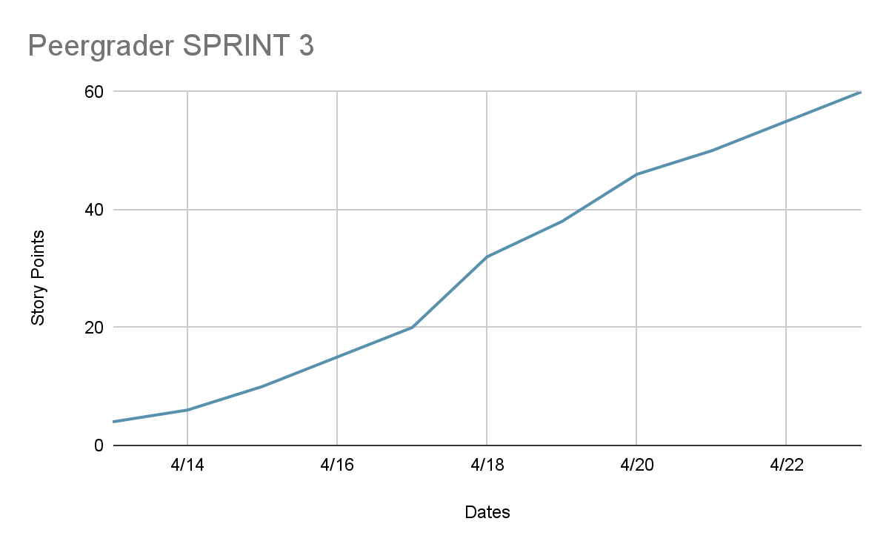

**SCRUM board**

| **User Story** | **Not Starter** | **In Progress** | **Done** |
| --- | --- | --- | --- |
| As an instructor I want students to get a grading score based on how well they graded others. | Compute the student’s score based on how “well” the student graded | Display the student’s grade  Compute the student’s score based on the student’s score  Rubric setting to adjust how the student gets a grade |  |
| As an instructor I want to be able to see the progress the class has made on turning in and grading. | Display a progress bar  Display all the students and their current progress |  |  |
| As a student I want to be able to see the scores I have been given and what I lost points for. | Display the breakdown of the student’s scores by student  Show which rubric rows were selected by each student  Show the comments/feedback from other students |  |  |
| As a student or teacher I want to be able to customize my profile. | Create a profile page  Change name  Change picture  Change email  Toggle notifications  Remove yourself from a class  Delete account |  |  |

**Schedule of Scrum meetings**

* When: Mon/Wed/Fri 9am-11am
* Where: Jack’s Lounge Baskin Engineering
* TA meeting: Monday 11-12pm ZOOM